______________________________________________________________

UM-SJTU JOINT INSTITUTE

INTRO TO CIRCUITS

(VE 215)

______________________________________________________________

LABORATORY REPORT

LAB 5

FILTER LAB

|  |  |  |
| --- | --- | --- |
| Name: Weikai Zhou | ID: 518021911039 |  |
| Date: 22 November 2019 |  |  |

1. **Introduction [1]**
   1. **Objectives**

* Learn about four types of filters – Low-Pass, High-Pass, Band-Pass, and Band-reject.
* Learn about transfer functions.
* Predict the theoretical result and make comparison with lab data.
  1. **Theoretical background & Apparatus**
     1. **Filter**

Filters are everywhere in our lives. The circuits built to operate on signals usually apply filters. For example, telephone lines pass the sounds at frequencies between about 100Hz and 3kHz and practically blocks all other frequencies.

* + 1. **Transfer function**

Mathematically, the transfer function is used to analyze what the circuit did to the signal:

$$transfer function=\frac{Output signal}{Input signal}$$

This function can also be expressed as

$$H\left(ω\right)=\frac{V_{out}\left(ω\right)}{V_{in}\left(ω\right)}$$

The magnitude of the transfer function is called “voltage gain”, often measured as the ratio of the peak-to-peak (ppk) voltages:

$$\left|H\left(ω\right)\right|=\left|\frac{V_{out}\left(ω\right)}{V_{in}\left(ω\right)}\right|=\frac{V_{out,ppk}\left(ω\right)}{V_{in,ppk}\left(ω\right)}$$

It is convenient to express and plot the magnitude of the transfer function on the logarithmic scale using decibels:

$${\left|H\left(ω\right)\right|}_{dB}=20\log_{10}\left(\frac{V_{out,ppk}\left(ω\right)}{V_{in,ppk}\left(ω\right)}\right)$$

Since both ppk voltages are always positive, the transfer function magnitude is positive and thus can always be converted to decibels. The use of decibels allows us to review data over a broad range.

* + 1. **Types of filters**

The figure below shows four main families of filters (Figure 1).

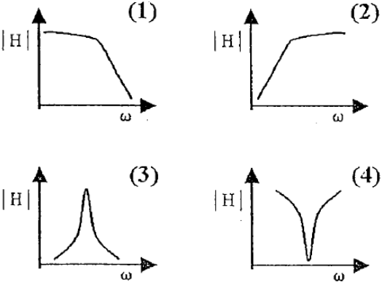Figure 1. Four main families of filters

They are (1) Low-Pass, (2) High-Pass, (3) Band-Pass and (4) Band-reject (also called band-stop or notch) respectively.

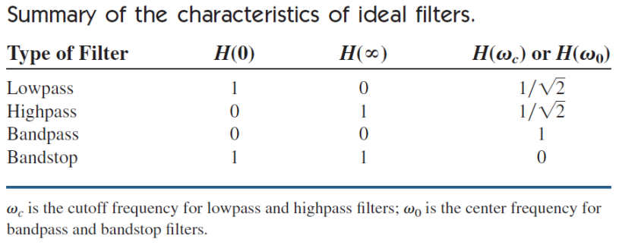 The table below summarizes the characteristics of ideal filters (Table 1).

Table 1. Summary of the characteristics of ideal filters

Filter circuits, which we are going to build in this lab, contain resistors, capacitors, and inductors. They are all passive filters.

* + 1. **High-pass filter**

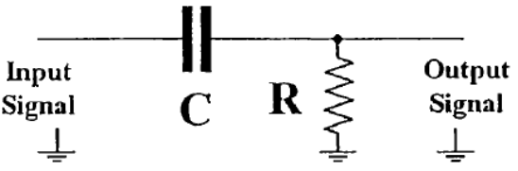The high-pass filter we are going to build uses a capacitor and a resistor (Figure 2)

Figure 2. A typical structure of high-pass filter

For the high-pass filter,

$$H\left(ω\right)=\frac{V_{out}\left(ω\right)}{V_{in}\left(ω\right)}=\frac{R}{R+\frac{1}{jωC}}=\frac{jωRC}{1+jωRC}$$

We should note that $H\left(0\right)=0$, $H\left(∞\right)=1$. Hence, it would only let high frequency pass.

* + 1. **Low-pass filter**

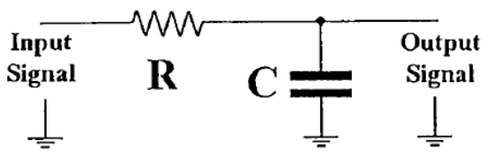The low-pass filter we are going to build uses a capacitor and a resistor (Figure 3).

Figure 3. A typical structure of low-pass filter

For the low-pass filter,

$$H\left(ω\right)=\frac{V_{out}\left(ω\right)}{V_{in}\left(ω\right)}=\frac{\frac{1}{jωC}}{R+\frac{1}{jωC}}=\frac{1}{1+jωRC}$$

We should note that $H\left(0\right)=1$, $H\left(∞\right)=0$. It would only let low frequency pass.

* + 1. **Band-pass filter**

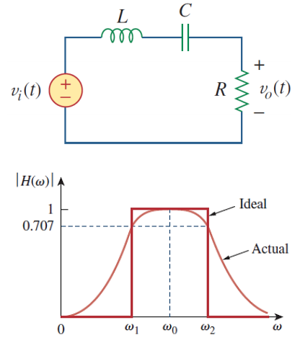The band-pass filter we are going to build uses a capacitor, an inductor and a resistor (Figure 4).

Figure 4. A typical structure of low-pass filter and the its function

For the band-pass filter,

$$H\left(ω\right)=\frac{V_{out}\left(ω\right)}{V_{in}\left(ω\right)}=\frac{R}{R+j\left(ωL-\frac{1}{ωC}\right)}$$

We should note that $H\left(0\right)=0$, $H\left(∞\right)=0$. The band-pass filter passes a band of frequencies centered on the center frequency $ω_{0}$, which is given by .

* + 1. **Band-stop filter**

The band-stop filter we are going to build uses a capacitor, an inductor and a resistor (Figure 5).

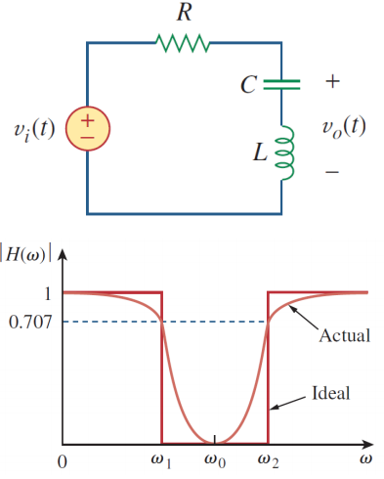Figure 5. A typical structure of band-stop filter and the its function

For the band-stop filter,

$$H\left(ω\right)=\frac{V_{out}\left(ω\right)}{V_{in}\left(ω\right)}=\frac{j\left(ωL-\frac{1}{ωC}\right)}{R+j\left(ωL-\frac{1}{ωC}\right)}$$

We should note that $H\left(0\right)=0$, $H\left(∞\right)=0$.the band-stop filter rejects a band of frequencies centered on the center frequency $ω_{0}$, which is given by .

* + 1. **Apparatus**

The experimental setup consists of function generator, oscilloscope and so on.

1. **Measurements [2]**
   1. According to the pre-lab assignments, we are supposed to fill in the Expected Data columns in the tables before the lab.
   2. During the lab:
2. We should construct the circuit for each type of filter. Resister: R = 982Ω; Capacitor: C = 0.1μF; Inductor: L = 1mH.
3. We should set the input signal in the function generator to be **Sine Wave** with amplitude of **5 $V_{ppk}$**  and change the frequency accordingly.
4. We should use the oscilloscope to detect the **amplitudes of the Input and Output signals**. Then, we should record them respectively in the first two column in the tables.
5. Additionally, for the **Band-reject Filter**, when the frequency approach the critical frequency at which the **Transfer Function Magnitude** reaches its minimum, the Output Signal Amplitude changes rapidly. For a more accurate result, we can (but not strictly required to) add some more rows to record the data.
   1. After the lab, we should calculate with the experimental data for the “**Transfer function magnitude**” and “**Transfer function magnitude, in dB**” columns.
6. **Results & discussion** **[2]**
7. **Low-pass filter**

According to the procedure described in 2.2., we can get the table below (Table 2). The theoretical value uses $H\left(ω\right)=\frac{V_{out}\left(ω\right)}{V_{in}\left(ω\right)}=\frac{\frac{1}{jωC}}{R+\frac{1}{jωC}}=\frac{1}{1+jωRC}$ and ${H\left(ω\right)}_{in dB}=20\log_{10}H\left(ω\right)$ to calculate.

|  |  |  |  |  |  |  |
| --- | --- | --- | --- | --- | --- | --- |
| Frequency | Input signal amplitude, $V_{ppk}$ | Output signal amplitude, (m) $V_{ppk}$ | Transfer function magnitude | Expected transfer function magnitude | Transfer function magnitude, in dB | Expected transfer function magnitude, in dB |
| 1 MHz | 4.8 | 32 | 0.0067 | 0.0016 | -43.5218 | -55.8058 |
| 100 kHz | 4.8 | 137 | 0.0285 | 0.0162 | -30.8904 | -35.8070 |
| 50 kHz | 4.9 | 253 | 0.0516 | 0.0324 | -25.7415 | -29.7898 |
| 10 kHz | 4.9 | 1200 | 0.2449 | 0.1600 | -12.2203 | -15.9184 |
| 5 kHz | 4.9 | 2200 | 0.4490 | 0.3084 | -6.9555 | -10.2191 |
| 1 kHz | 5.1 | 4900 | 0.9608 | 0.8510 | -0.3475 | -1.4010 |
| 500 Hz | 5.2 | 5100 | 0.9808 | 0.9556 | -0.1687 | -0.3948 |

Table 2. Data for low-pass filters

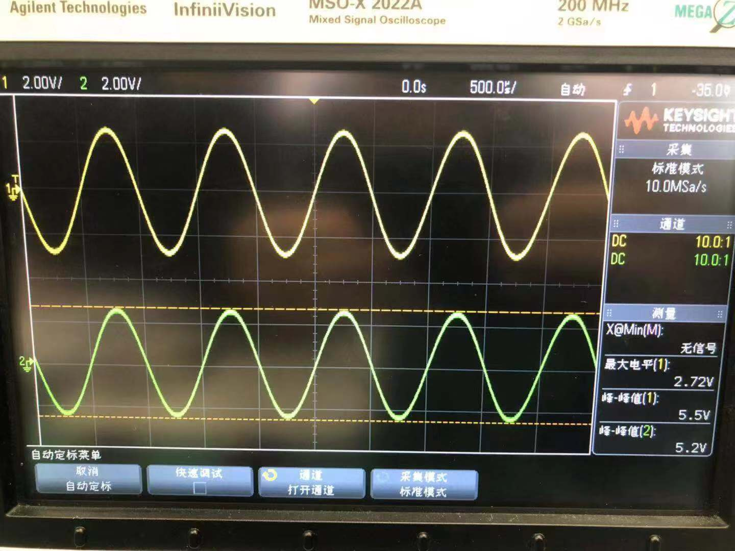One of the pictures taken during this process is shown below (Figure 6).

Figure 6. One of the pictures taken for low-pass filters

Using the first measurement as an example, we can calculate the transfer function magnitude and transfer function magnitude, in dB as follows

$$transfer function magnitude=\frac{V_{out}\left(ω\right)}{V_{in}\left(ω\right)}=\frac{32×{10}^{-3}}{4.8}=0.0067$$

$$transfer function magnitude, in dB=20\log_{10}0.0067=-43.5218$$

Then, we can calculate the rest measurements and finish Table 2.

And using the first measurement, we can calculate the relative error as follows

$${relative error}_{transfer function magnitude}=\frac{0.0067-0.0016}{0.0016}×100\%=318.75\%$$

$${relative error}_{transfer function magnitude, in dB}=\frac{-43.5218+55.8058}{55.8058}×100\%=22.01\%$$

Then, we can get the Table 3 below for the rest data.

|  |  |  |
| --- | --- | --- |
| Frequency | Relative error for transfer function magnitude | Relative error for transfer function magnitude, in dB |
| 1 MHz | 318.75% | 22.01% |
| 100 kHz | 75.93% | 13.73% |
| 50 kHz | 59.26% | 13.59% |
| 10 kHz | 53.06% | 23.23% |
| 5 kHz | 45.59% | 31.94% |
| 1 kHz | 12.90% | 75.20% |
| 500 Hz | 2.64% | 57.27% |

Table 3. Relative error for measurements

From this table, we can know that the relative error is large. We may think that this is because that (1) the filter is not ideal; (2) there is resistance in the wire; (3) the connection is not good; (4) the precision of the instrument is not high.

1. **High-pass filter**

According to the procedure described in 2.2., we can get the table below (Table 4). The theoretical value uses $H\left(ω\right)=\frac{V_{out}\left(ω\right)}{V_{in}\left(ω\right)}=\frac{R}{R+\frac{1}{jωC}}=\frac{jωRC}{1+jωRC}$ and ${H\left(ω\right)}_{in dB}=20\log_{10}H\left(ω\right)$ to calculate.

|  |  |  |  |  |  |  |
| --- | --- | --- | --- | --- | --- | --- |
| Frequency | Input signal amplitude, $V_{ppk}$ | Output signal amplitude, (m) $V_{ppk}$ | Transfer function magnitude | Expected transfer function magnitude | Transfer function magnitude, in dB | Expected transfer function magnitude, in dB |
| 1 MHz | 4.7 | 5600 | 1.1915 | 1.0000 | 1.5218 | 0.0000 |
| 100 kHz | 4.8 | 5600 | 1.1667 | 0.9999 | 1.3389 | -0.0011 |
| 50 kHz | 4.9 | 5600 | 1.1429 | 0.9995 | 1.1598 | -0.0045 |
| 10 kHz | 4.9 | 5500 | 1.1224 | 0.9871 | 1.0033 | -0.1126 |
| 5 kHz | 4.9 | 5110 | 1.0429 | 0.9513 | 0.3645 | -0.4339 |
| 1 kHz | 5.1 | 2490 | 0.4882 | 0.5251 | -6.2274 | -5.5951 |
| 500 Hz | 5.2 | 1330 | 0.2558 | 0.2948 | -11.8430 | -10.6095 |
| 100 Hz | 5.1 | 279 | 0.0547 | 0.0616 | -25.2393 | -24.2097 |

Table 4. Data for high-pass filters

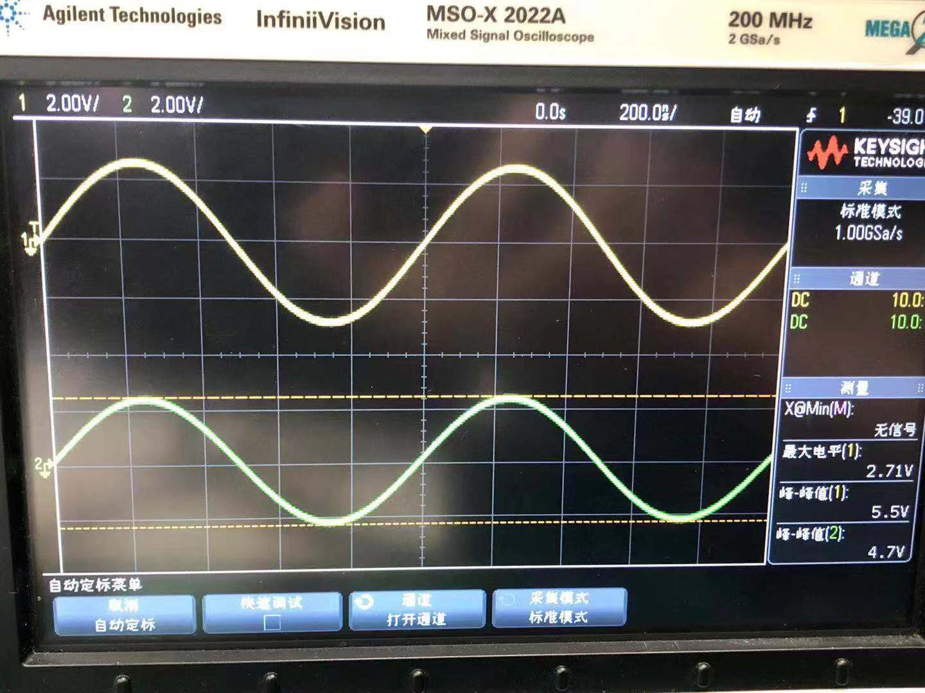One of the pictures taken during this process is shown below (Figure 7).

Figure 7. One of the pictures taken for high-pass filters

Using the first measurement as an example, we can calculate the transfer function magnitude and transfer function magnitude, in dB as follows

$$transfer function magnitude=\frac{V_{out}\left(ω\right)}{V_{in}\left(ω\right)}=\frac{5600×{10}^{-3}}{4.7}=1.1915$$

$$transfer function magnitude, in dB=20\log_{10}1.1915=1.5218$$

Then, we can calculate the rest measurements and finish Table 3.

And using the first measurement, we can calculate the relative error as follows

$${relative error}_{transfer function magnitude}=\frac{1.1915-1.0000}{1.0000}×100\%=19.15\%$$

$${relative error}_{transfer function magnitude, in dB}=\frac{1.5218-0}{0}×100\%=∞$$

Then, we can get the Table 5 below for the rest data.

|  |  |  |
| --- | --- | --- |
| Frequency | Relative error for transfer function magnitude | Relative error for transfer function magnitude, in dB |
| 1 MHz | 19.15% | $$∞$$ |
| 100 kHz | 16.68% | 121818.18% |
| 50 kHz | 14.35% | 25873.33% |
| 10 kHz | 13.71% | 991.03% |
| 5 kHz | 9.63% | 184.01% |
| 1 kHz | 7.03% | 11.30% |
| 500 Hz | 13.23% | 11.63% |
| 100 Hz | 11.20% | 4.25% |

Table 5. Relative error for measurements

From this table, we can know that some of the relative errors are large. We may think that this is because that (1) the filter is not ideal; (2) there is resistance in the wire; (3) the connection is not good; (4) the precision of the instrument is not high. Besides, we find some cases that transfer function magnitude is larger than 1. We think this is mainly due to the non-ideal filter.

1. **Band-pass filter**

According to the procedure described in 2.2., we can get the table below (Table 6). The theoretical value uses $H\left(ω\right)=\frac{V_{out}\left(ω\right)}{V_{in}\left(ω\right)}=\frac{R}{R+j\left(ωL-\frac{1}{ωC}\right)}$ and ${H\left(ω\right)}_{in dB}=20\log_{10}H\left(ω\right)$ to calculate.

|  |  |  |  |  |  |  |
| --- | --- | --- | --- | --- | --- | --- |
| Frequency | Input signal amplitude, $V_{ppk}$ | Output signal amplitude, (m) $V_{ppk}$ | Transfer function magnitude | Expected transfer function magnitude | Transfer function magnitude, in dB | Expected transfer function magnitude, in dB |
| 1 MHz | 5.0 | 580 | 0.1160 | 0.1545 | -18.7108 | -16.2240 |
| 500 kHz | 5.0 | 1650 | 0.3300 | 0.2986 | -9.6297 | -10.4981 |
| 100 kHz | 4.9 | 4900 | 1.0000 | 0.8484 | 0.0000 | -1.4275 |
| 50 kHz | 4.8 | 5400 | 1.1250 | 0.9610 | 1.0231 | -0.3455 |
| 10 kHz | 4.8 | 5500 | 1.1458 | 0.9952 | 1.1824 | -0.0418 |
| 1 kHz | 5.1 | 2410 | 0.4725 | 0.5265 | -6.5111 | -5.5716 |
| 500 Hz | 5.1 | 1290 | 0.2529 | 0.2951 | -11.9396 | -10.6009 |

Table 6. Data for band-pass filters

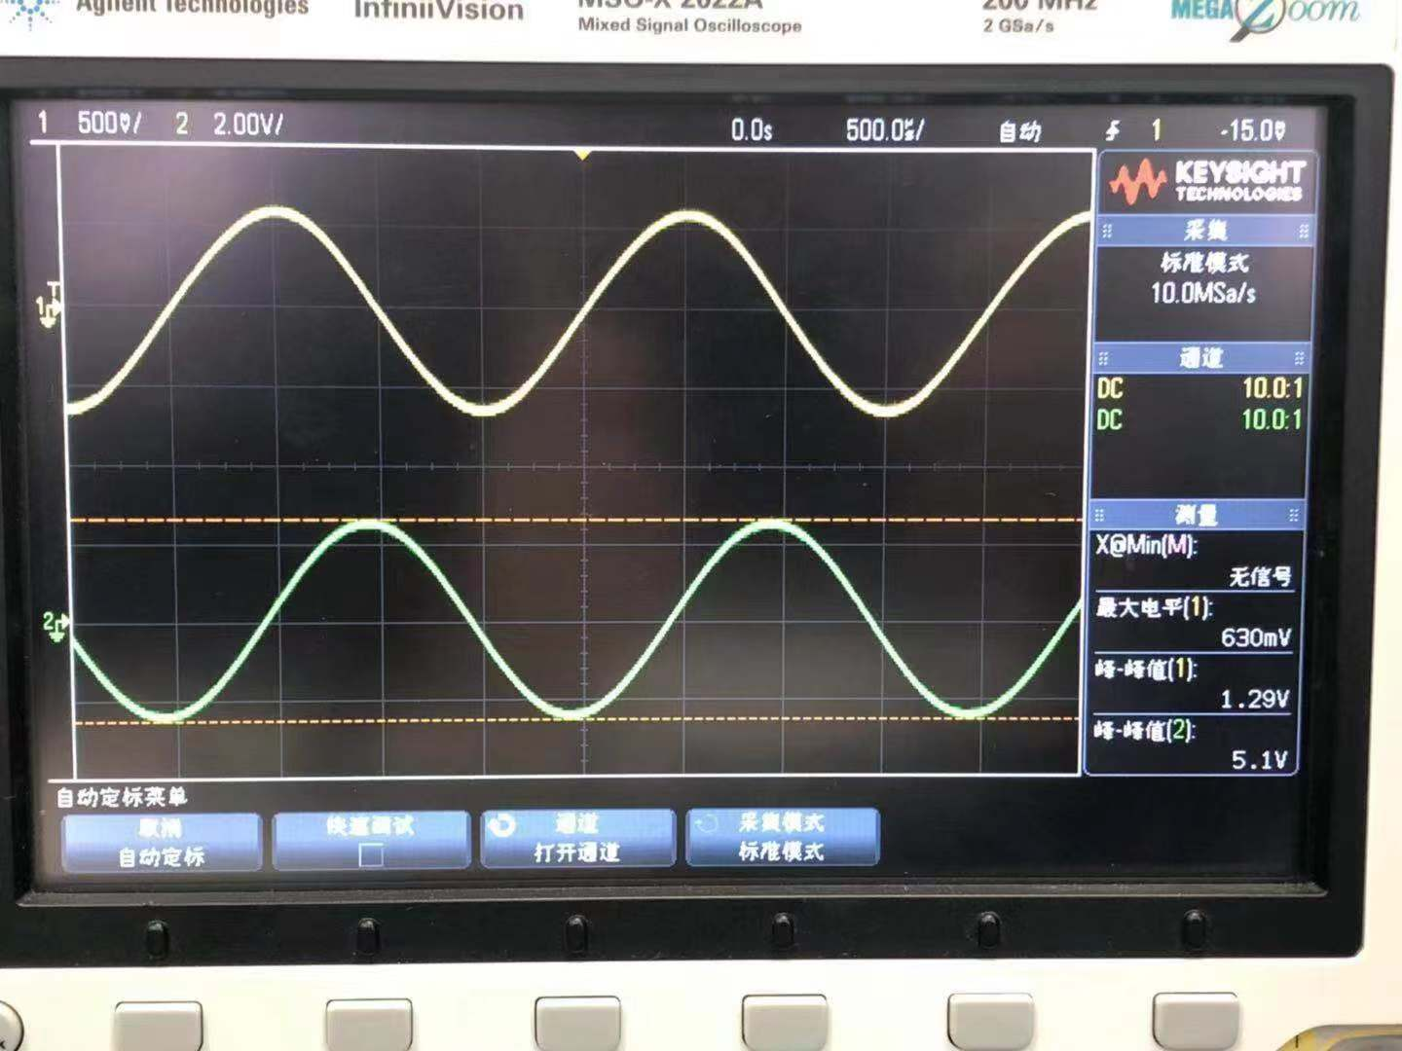One of the pictures taken during this process is shown below (Figure 8).

Figure 8. One of the pictures taken for band-pass filters

Using the first measurement as an example, we can calculate the transfer function magnitude and transfer function magnitude, in dB as follows

$$transfer function magnitude=\frac{V_{out}\left(ω\right)}{V_{in}\left(ω\right)}=\frac{580×{10}^{-3}}{5.0}=0.1160$$

$$transfer function magnitude, in dB=20\log_{10}0.1160=-18.7108$$

Then, we can calculate the rest measurements and finish Table 4.

And using the first measurement, we can calculate the relative error as follows

$${relative error}_{transfer function magnitude}=\frac{0.1545-0.1160}{0.1545}×100\%=24.92\%$$

$${relative error}_{transfer function magnitude, in dB}=\frac{-16.2240+18.7108}{16.2240}×100\%=15.33\%$$

Then, we can get the Table 7 below for the rest data.

|  |  |  |
| --- | --- | --- |
| Frequency | Relative error for transfer function magnitude | Relative error for transfer function magnitude, in dB |
| 1 MHz | 24.92% | 15.33% |
| 500 kHz | 10.52% | 8.27% |
| 100 kHz | 17.87% | 100.00% |
| 50 kHz | 17.07% | 396.12% |
| 10 kHz | 15.13% | 2928.71% |
| 1 kHz | 10.26% | 16.86% |
| 500 Hz | 14.30% | 12.63% |

Table 7. Relative error for measurements

From this table, we can know that some of the relative errors are large. We may think that this is because that (1) the filter is not ideal; (2) there is resistance in the wire; (3) the connection is not good; (4) the precision of the instrument is not high. Besides, we find some cases that transfer function magnitude is larger than 1. We think this is mainly due to the non-ideal filter.

1. **Band-reject filter**

According to the procedure described in 2.2., we can get the table below (Table 8). The theoretical value uses $H\left(ω\right)=\frac{V_{out}\left(ω\right)}{V_{in}\left(ω\right)}=\frac{j\left(ωL-\frac{1}{ωC}\right)}{R+j\left(ωL-\frac{1}{ωC}\right)}$ and ${H\left(ω\right)}_{in dB}=20\log_{10}H\left(ω\right)$ to calculate.

|  |  |  |  |  |  |  |
| --- | --- | --- | --- | --- | --- | --- |
| Frequency | Input signal amplitude, $V_{ppk}$ | Output signal amplitude, (m) $V_{ppk}$ | Transfer function magnitude | Expected transfer function magnitude | Transfer function magnitude, in dB | Expected transfer function magnitude, in dB |
| 1 MHz | 5.0 | 5800 | 1.1600 | 0.9880 | 1.2892 | -0.1049 |
| 500 kHz | 5.0 | 5600 | 1.1200 | 0.9544 | 0.9844 | -0.4056 |
| 300 kHz | 5.0 | 5200 | 1.0400 | 0.8863 | 0.3407 | -1.0481 |
| 200 kHz | 4.9 | 4600 | 0.9388 | 0.7860 | -0.5488 | -2.0911 |
| 100 kHz | 4.8 | 2930 | 0.6104 | 0.5292 | -4.2875 | -5.5282 |
| 50 kHz | 4.8 | 1490 | 0.3104 | 0.2763 | -10.1611 | -11.1721 |
| 10 kHz | 4.9 | 840 | 0.1714 | 0.0976 | -15.3183 | -20.2092 |
| 5 kHz | 4.9 | 1970 | 0.4020 | 0.2804 | -7.9146 | -11.0435 |
| 1 kHz | 5.1 | 4900 | 0.9608 | 0.8501 | -0.3475 | -1.4105 |
| 500 Hz | 5.2 | 5100 | 0.9808 | 0.9555 | -0.1687 | -0.3956 |

Table 8. Data for band-reject filters

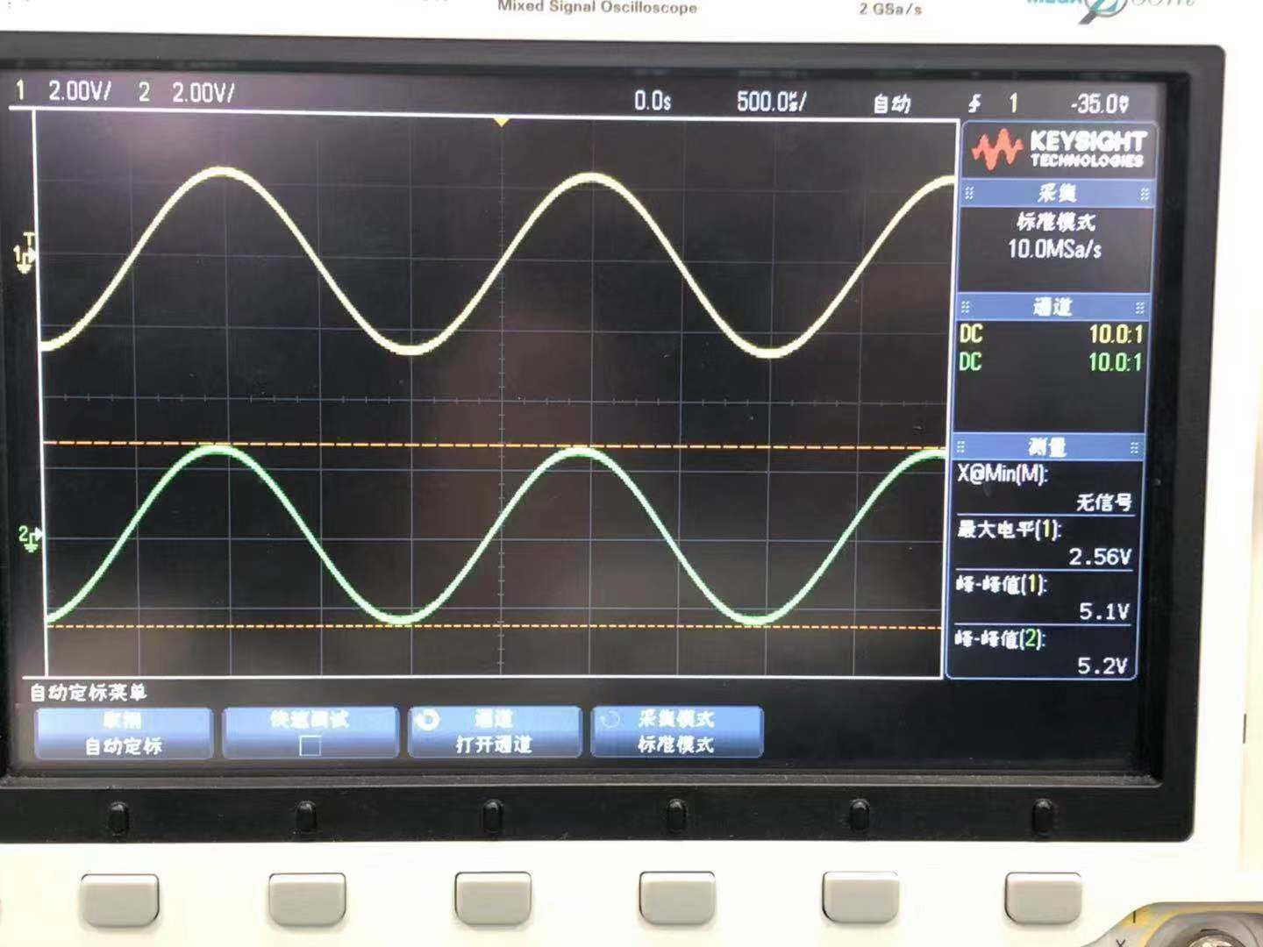One of the pictures taken during this process is shown below (Figure 9).

Figure 9. One of the pictures taken for band-reject filters

Using the first measurement as an example, we can calculate the transfer function magnitude and transfer function magnitude, in dB as follows

$$transfer function magnitude=\frac{V_{out}\left(ω\right)}{V_{in}\left(ω\right)}=\frac{5800×{10}^{-3}}{5.0}=1.1600$$

$$transfer function magnitude, in dB=20\log_{10}1.1600=1.2892$$

Then, we can calculate the rest measurements and finish Table 5.

And using the first measurement, we can calculate the relative error as follows

$${relative error}_{transfer function magnitude}=\frac{1.1600-0.9880}{0.9880}×100\%=17.41\%$$

$${relative error}_{transfer function magnitude, in dB}=\frac{1.2892+0.1049}{0.1049}×100\%=1328.98\%$$

Then, we can get the Table 9 below for the rest data.

|  |  |  |
| --- | --- | --- |
| Frequency | Relative error for transfer function magnitude | Relative error for transfer function magnitude, in dB |
| 1 MHz | 17.41% | 1328.98% |
| 500 kHz | 17.35% | 342.70% |
| 300 kHz | 17.34% | 132.51% |
| 200 kHz | 19.44% | 73.76% |
| 100 kHz | 15.34% | 22.44% |
| 50 kHz | 12.34% | 9.05% |
| 10 kHz | 75.61% | 24.20% |
| 5 kHz | 43.37% | 28.33% |
| 1 kHz | 13.02% | 75.36% |
| 500 Hz | 2.65% | 57.36% |

Table 9. Relative error for measurements

From this table, we can know that some of the relative errors are large. We may think that this is because that (1) the filter is not ideal; (2) there is resistance in the wire; (3) the connection is not good; (4) the precision of the instrument is not high. Besides, we find some cases that transfer function magnitude is larger than 1. We think this is mainly due to the non-ideal filter.

1. **Conclusions [1]**

In this experiment, we learn about four types of filters – Low-Pass, High-Pass, Band-Pass, and Band-reject. We also learn about transfer functions and predict the theoretical result and make comparison with lab data. We measured the transfer function magnitudes for the four types. All of the objectives have been achieved. Therefore, the experiment is quite successful.

In our calculation, we find that some of the relative errors are large. We may think that this is because that (1) the filter is not ideal; (2) there is resistance in the wire; (3) the connection is not good; (4) the precision of the instrument is not high. Besides, we find some cases that transfer function magnitude is larger than 1. We think this is mainly due to the non-ideal filter.

1. **References**

[1] Lab5_Filter Lab_Manual

[2] Lab5_Filter Lab_DataSheet